
SOP Title: | eComm Finding Return Fraud
Document Storage Location: | STACS/Management/SOPs – Logistics and Warehousing | Document #: | SEASOP394v100
SOP Originator: | Kyla Cook | Last Edited by: | Torino Thomas
Effective Date: | 8/14/2020 | Last Edited Date: | 11/12/2020
Other:

- Purpose
  - This Standard Operating Procedure (SOP) extablishes proesses, procedures, and standards for the eCommerce (eComm) returns fraud identification process within the Samsung (SEA) eComm Returns Operations.
- Scope
  - Coppell eComm: This SOP establishes policy and responsibilities governing the Samsung eComm Frauds Identification Process.
- Responsibilities
  - SEA eComm: Is responsible for looking for fraud on packages in transit to the warehouse and those packages which just arrived.
  - 3PL (GEODIS): Is responsible for identifying when material being received does not physically match the packing list or the system.
- Instructions
  - Package Received: Add the below to “Suspected Fraud Received” tracker
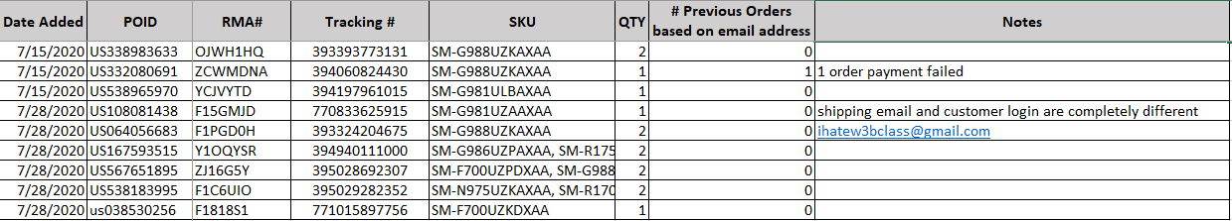
    - Start looking at possible fraud if the following conditions apply for any package
      - Shipping box is empty
      - Product box does not contain expected device
      - The package contains an item that is not sold on Samsung.com
        - Found by searching Samsung.com to see if Samsung sells this item
        - If there is no SKU on package it is not Samsung’s
    - Indicators of Possible Fraud:
      - Shipping Address anomalies:
        - When the distance from the customers home (shipping) address to the Return Tracking Address [where the package is received (picked-up) by FedEx] either:
          - Requires more than an hour drive, or
          - Are in different states and more than an hour drive
      - Weight discrepancy: The package weight listed on FedEx.com under Shipment Facts (when looking at a specific tracking number) is more than V4 or FedEx’s systems’ estimated item weight
        - Example: If the customer documents sending back one (1) phone.
          - The type of phone is roughly 1 (one) lbs.
          - But the FedEx.com weight of the package is 10 lbs
          - That would be suspected fraud.
      - Common Fraud Scenario:
        - The customer is a first time customer on Samsung.com and they order one or two of the newest phone, then try to return them because of something similar to “Change of Mind”
      - Label alterations: Customer changes information on the label sent by SEA
        - Shipping label on the package is addressed to another address but has a Samsung PO ID and/or RMA attached to the shipment information under the FedEx shipment information tab.
          - Note FedEx basis address on the tracking number so SEA receives package.
          - SEA looks it up by tracking number and sees an incorrect city
          - FedEx looks up the tracking number and they will see that it is addressed to another organization
            - Common organizations are Shaw Floors, Sandusky Lee Corporation, Ruben’s All Auto Repair, and Irina Arsenteva
      - Customer’s Previous Fraud Orders
        - Can be checked by taking the email or billing/shipping phone number from V4 and using that in the search engine to find previous order “Status”
        - If multiple orders pop up may show past fraud under that email or billing/shipping phone number.
  - Package Not Received: Add the below to “Suspected Fraud Not Received” tracker
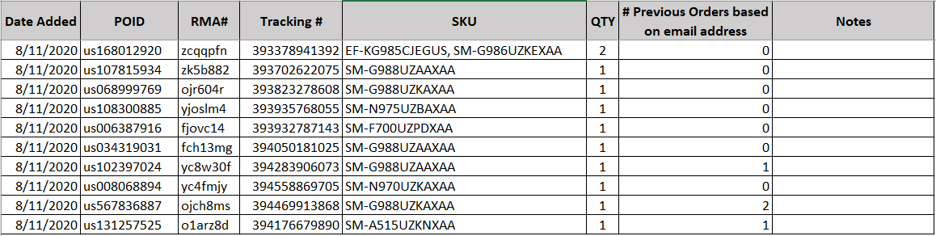
    - When packages show up on the FedEx.com aging report SEA will research to determine if Fraud is suspected.
    - Research can be done in the same manner as above.
      - Use the tracking number to see if anything stands out on FedEx.com that makes it seem that more research should be done.
    - For example: Material may have been delivered to the wrong address but we do not know the person who signed for it.
      - Check whether the city was changed on label, etc.
  - Note: Remember that some customers genuinely send in the incorrect item on accident

